Cabo Verde

## GNI per capita and development level

The data set shows the GNI per capita and development level of the country each year.

## # A tibble: 19 x 5  
## country iso3c date GNIperCapita devCategory   
## <chr> <chr> <dbl> <dbl> <chr>   
## 1 Cabo Verde CPV 1996 36014. High Income   
## 2 Cabo Verde CPV 1998 37980. High Income   
## 3 Cabo Verde CPV 2000 4105. Upper Middle Income  
## 4 Cabo Verde CPV 2002 4991. Upper Middle Income  
## 5 Cabo Verde CPV 2003 4983. Upper Middle Income  
## 6 Cabo Verde CPV 2004 4983. Upper Middle Income  
## 7 Cabo Verde CPV 2005 60325. High Income   
## 8 Cabo Verde CPV 2006 60325. High Income   
## 9 Cabo Verde CPV 2007 3212. Lower Middle Income  
## 10 Cabo Verde CPV 2008 3365. Lower Middle Income  
## 11 Cabo Verde CPV 2009 3285. Lower Middle Income  
## 12 Cabo Verde CPV 2010 3230. Lower Middle Income  
## 13 Cabo Verde CPV 2011 3334. Lower Middle Income  
## 14 Cabo Verde CPV 2012 3316. Lower Middle Income  
## 15 Cabo Verde CPV 2013 3327. Lower Middle Income  
## 16 Cabo Verde CPV 2014 3253. Lower Middle Income  
## 17 Cabo Verde CPV 2015 3288. Lower Middle Income  
## 18 Cabo Verde CPV 2016 3406. Lower Middle Income  
## 19 Cabo Verde CPV 2017 3494. Lower Middle Income

## GDP growth and economic growth classification

The data set shows the GDP growth and the ecomic growth classification of the country each year.

## # A tibble: 19 x 5  
## country iso3c date GDPannualGrowthRate GDPgrowthCategory4  
## <chr> <chr> <dbl> <dbl> <fct>   
## 1 Cabo Verde CPV 1996 11.3 fast growth   
## 2 Cabo Verde CPV 1998 12.5 fast growth   
## 3 Cabo Verde CPV 2000 14.3 fast growth   
## 4 Cabo Verde CPV 2002 5.25 moderate growth   
## 5 Cabo Verde CPV 2003 4.18 moderate growth   
## 6 Cabo Verde CPV 2004 10.2 fast growth   
## 7 Cabo Verde CPV 2005 6.91 fast growth   
## 8 Cabo Verde CPV 2006 7.98 fast growth   
## 9 Cabo Verde CPV 2007 15.2 fast growth   
## 10 Cabo Verde CPV 2008 6.65 fast growth   
## 11 Cabo Verde CPV 2009 -1.27 negative grwoth   
## 12 Cabo Verde CPV 2010 1.47 slow growth   
## 13 Cabo Verde CPV 2011 3.97 moderate growth   
## 14 Cabo Verde CPV 2012 1.08 slow growth   
## 15 Cabo Verde CPV 2013 0.803 slow growth   
## 16 Cabo Verde CPV 2014 0.611 slow growth   
## 17 Cabo Verde CPV 2015 1.01 slow growth   
## 18 Cabo Verde CPV 2016 4.71 moderate growth   
## 19 Cabo Verde CPV 2017 3.70 moderate growth

## Development trend

The plot shows the development trend of the country.

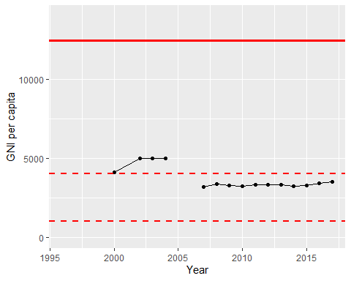

GNI Per Capita Trend